Tällberg-SNF-Eliasson Global Leadership Prize 2024 Winners
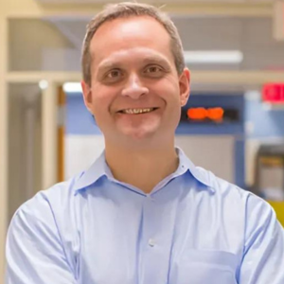
Kristian Olson: American internist, pediatrician, educator, and human-centered designer of global health care solutions, based at Harvard Medical School.

Olson combines an active medical practice at Massachusetts General Hospital and Mass General Brigham with his leadership of the Springboard Studio (where he is Vice President of Design Impact at Mass General Brigham Health) and of the Consortium for Affordable Medical Technologies (CAMTech), which he co-founded. In both he is instrumental in developing innovative, high and low tech, health care solutions primarily for low and middle-income countries but with applicability to the United States as well.

Kris is a serial innovator. He has several patents and has started both non-profit and for-profit ventures to accelerate ideas to implementation.

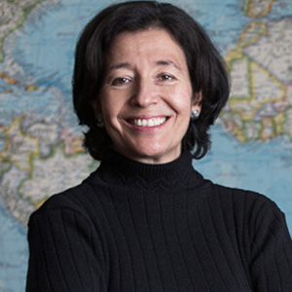
María Teresa Ronderos: a highly respected Colombian journalist and co-founder of the Latin American Centre for Investigative Journalism (CLIP).

Ronderos is well known as a journalist who champions press freedom and the power of collaborative investigation to hold power to account. Since CLIP’s inception in 2019, Ronderos has coordinated many of the 40+ cross-border investigations the collaborative has produced. In collaboration with 140 media partners throughout the Americas, these investigations have addressed issues such as migration, disinformation, energy transition and corruption.

Her contributions to journalism have earned her numerous national and international awards. She serves on the boards of Media Defense and the Committee to Protect Journalists, among others.
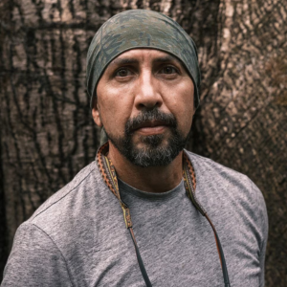
Fernando Trujillo: Colombia-based marine biologist, conservationist, global expert on river dolphins, and activist who works to protect aquatic ecosystems in the Amazon and beyond.

Over nearly four decades Trujillo has combined deep expertise as a world-class expert on river dolphins with a recognition that successful conservation requires the development of coalitions with communities, governments, research institutions, and indigenous peoples. The result has been pioneering governance initiatives aimed at conserving large river systems such as the Amazon and Orinoco—benefitting both river dolphins and the people live along the rivers.

Trujillo founded Fundación Omacha and is an active participant in a range of global scientific organizations. His professional work encompasses aquatic ecology, endangered species, wetlands, fisheries agreements, species management plans and protected areas, wildlife monitoring, environmental impact assessments, and toxics in aquatic systems.

Tällberg Foundation Board Members

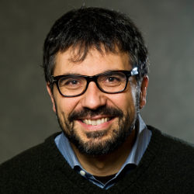
Fiorenzo Omenetto: Italian/American academic and materials engineer working at the interface of technology, biologically inspired materials, and the natural sciences.

Omenetto, Frank C. Doble Professor of Engineering and Professor of Biomedical Engineering and a Special Advisor to the Provost, Tufts University, imagines and develops truly sustainable materials for high-technology applications. In particular, he has pioneered the use of silk as a sustainable material platform for a widespread array of advanced technology and design applications

Fio is a past winner of the Tällberg-SNF-Eliasson Global Leadership Prize.
.
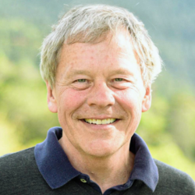
Alan Stoga, Chairman, Tällberg Foundation and American strategist, entrepreneur, and consultant focused on geopolitics and economics.

Stoga has led the Tällberg Foundation for the past decade, developing new initiatives in leadership recognition (Tällberg-SNF-Eliasson Global Leadership Prize), mentoring (Tällberg Leaders Mentoring Leaders) and programming (New Thinking for a New World podcast) and an innovative partnership with the Stavros Niarchos Foundation.

His career has included strategic communications and public relations, corporate consulting, digital media publishing, geopolitics, banking, and government. He has worked as a consultant to major multinationals as well as governments,

